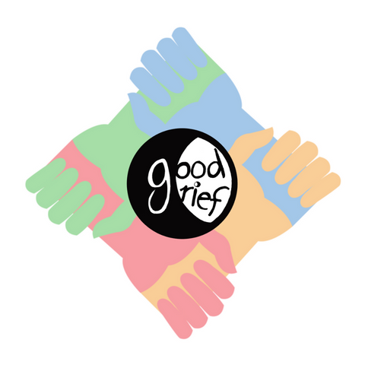
Good Grief Bay Area presents:
From Grief to Grit!

A weekly climate change support circle that combines Good Grief Network’s 10-step personal resilience program with meaningful community engagement, to build individual strength and inspire collective, local action

In this time of ecological collapse, festering social injustice, and isolating consumerism, we invite you to gather with us to assert our mutual humanity and harness the healing power of community. Now more than ever, we are called to support each other in exploring and embracing the traumas of our civilization—past, present, and future—while strengthening our personal and collective resilience and inspiring meaningful action, so that we may work together to address the converging crises that affect us here in the Bay Area.

Mondays, 7-9 pm
Oct 7th to Dec 16th, 2019
Oakland Hills, Montclair
Join us for an 11-week, in-person ecological grief and climate action support circle in Oakland. This intimate, inclusive group will meet weekly and follow the 10-step personal resilience program piloted by Good Grief Network (GoodGriefnetwork.org), which aims to help people awaken to the climate crisis, and combat despair, inaction, and eco-anxiety.
For the first time, we are bringing this curriculum to the Bay Area, so that the skills and tools acquired from Good Grief’s step-work may find their way into the eager minds and hands of concerned Bay Area residents who are ready to heal and get to work! Through art, ritual, open-hearted sharing, and direct community engagement, we will co-create and enact a vision for the way forward.

To join please email grief2grit@googlegroups.com and include a two-paragraph description of who you are and why you are called to participate in this program. We are looking for committed individuals who can attend at least 10 of the 11 weekly meetings.

Cost: free

